Report
Project name: Nexus social
Section:L52
instructor name: Mucahid Kutlu

Student contribution
Durrah Babiker 202209145 | Statistics (FULL) + DB+prisma | 150%
Alanoud Alromaihi  202001584 | Seed + Data | 100%
Maryam Al-ansari  202204151 | DB Design + Prisma Schema | 50%
Manasek Ahmed 201808251 | APIs + Repository + Report Finishing | 100%

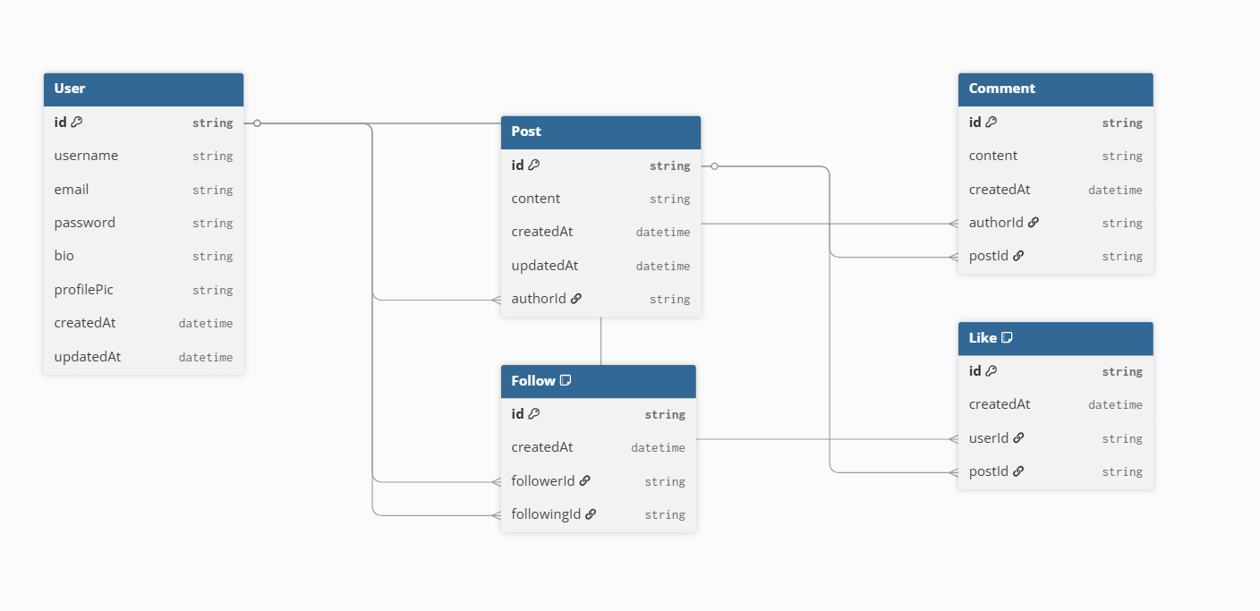

1. Database Queries
The system uses Prisma ORM to interact with the database. Prisma simplifies database operations in code, but each operation corresponds to an underlying SQL query. The following are the equivalent SQL queries used in the system.

1.1 Deleting Existing Data
Before inserting new data, the system clears all existing records to avoid duplication.
DELETE FROM Like;
DELETE FROM Comment;
DELETE FROM Follow;
DELETE FROM Post;
DELETE FROM User;
Explanation:
These queries remove all records from the database tables to ensure a clean state before seeding new data.

1.2 Inserting Users
INSERT INTO User (username, email, password, bio)
VALUES ('alice_wonder', 'alice@nexus.com', 'hashed_password', 'Curious developer');
Explanation:
This query inserts new users into the system. Passwords are securely stored after being hashed.

1.3 Inserting Posts
INSERT INTO Post (content, authorId)
VALUES ('Just pushed a huge refactor to production...', 1);
Explanation:
Each post is linked to a user using the authorId foreign key.

1.4 Inserting Comments
INSERT INTO Comment (content, authorId, postId)
VALUES ('This is so relatable.', 2, 1);
Explanation:
Comments are associated with both the user (author) and the post.

1.5 Inserting Likes
INSERT INTO Like (userId, postId)
VALUES (3, 1);
Explanation:
This query records a like from a user on a specific post.

1.6 Inserting Follow Relationships
INSERT INTO Follow (followerId, followingId)
VALUES (1, 2);
Explanation:
This represents a relationship where one user follows another.

1.7 Retrieving Data (SELECT Queries)
The system also retrieves data using SELECT queries.
SELECT * FROM Post;
Explanation:
Fetches all posts from the database.

SELECT Post.content, User.username
FROM Post
JOIN User ON Post.authorId = User.id;
Explanation:
Retrieves posts along with the usernames of their authors using a JOIN operation.

